# Templates

Quarter - Real Estate HTML Template

<https://maelectrics.com/tf/html/>

# dasreinvestments.com

index.html – Top Head

index-2.html – Main

<file:///C:/xampp/htdocs/in/index-5.html>

# Colors

#ff5a3c

class="white-color"

white-color

ltn__upcoming-project-item

<https://nulled-scripts.cc/page/7/?s=Real+Estate+html>

### [Jagga – Real Estate HTML Template](https://themeforest.net/item/jagga-real-estate-html-template/28870091)

[https://themeforest.net/item/ortiz-real-estate-html5-template/25281330](http://www.lolinez.com/?https://themeforest.net/item/ortiz-real-estate-html5-template/25281330)

<https://www.themelock.com/othertemplates/687010250-windsor-v10-apartment-complex-single-property-site-template.html>

<https://www.themelock.com/othertemplates/687020809-celfie-v10-bootstrap-3x-multi-purpose-html5-template.html>

<https://www.themelock.com/othertemplates/687016809-porto-v80-responsive-html5-template.html>

<https://www.themelock.com/othertemplates/687017948-unibody-v110-multipurpose-one-multi-page-html5-template.html>

<https://www.themelock.com/othertemplates/687011546-berserk-v194-business-portfolio-blog-corporate-ecommerce-app-with-page-builder.html>

### [Quarter - Real Estate HTML Template With RTL](https://themeforest.net/item/quarter-real-estate-html-template/32310641)

<https://maelectrics.com/tf/html/quarter-preview/quarter/index-9.html>

<https://preview.themeforest.net/item/jagga-real-estate-html-template/full_screen_preview/28870091?_ga=2.165637882.458846476.1630482077-1998332570.1630477619>

https://www.themelock.com/othertemplates/687019612-octavian-v10-multipurpose-creative-html5-template.html

# Website Ref.s

[2:35 AM, 9/1/2021] Shajahan CEO: <https://ravenmf.com/>

[2:40 AM, 9/1/2021] Shajahan CEO: <https://appleswaygroup.com/>

[2:47 AM, 9/1/2021] Shajahan CEO: <http://www.growwealth2retire.com/>

[2:49 AM, 9/1/2021] Shajahan CEO: FORM LIKE THIS NEEDED EMBEDDED APPOINTMENTS: <https://calendly.com/>

[2:49 AM, 9/1/2021] Shajahan CEO: FORM LIKE THIS NEEDED TO BE EMBEDDED: <https://docs.google.com/forms/d/e/1FAIpQLSeDkiPEu8lTXFBZM7j-To1ya-ALJ1xmX1T1t5qOXY7W3W7gFQ/viewform>

[2:52 AM, 9/1/2021] Shajahan CEO: Database for this Potential investor form needed use google forms & backend Database or front end PHP/API & backend database

[www.dasreinvestments.com](http://www.dasreinvestments.com)

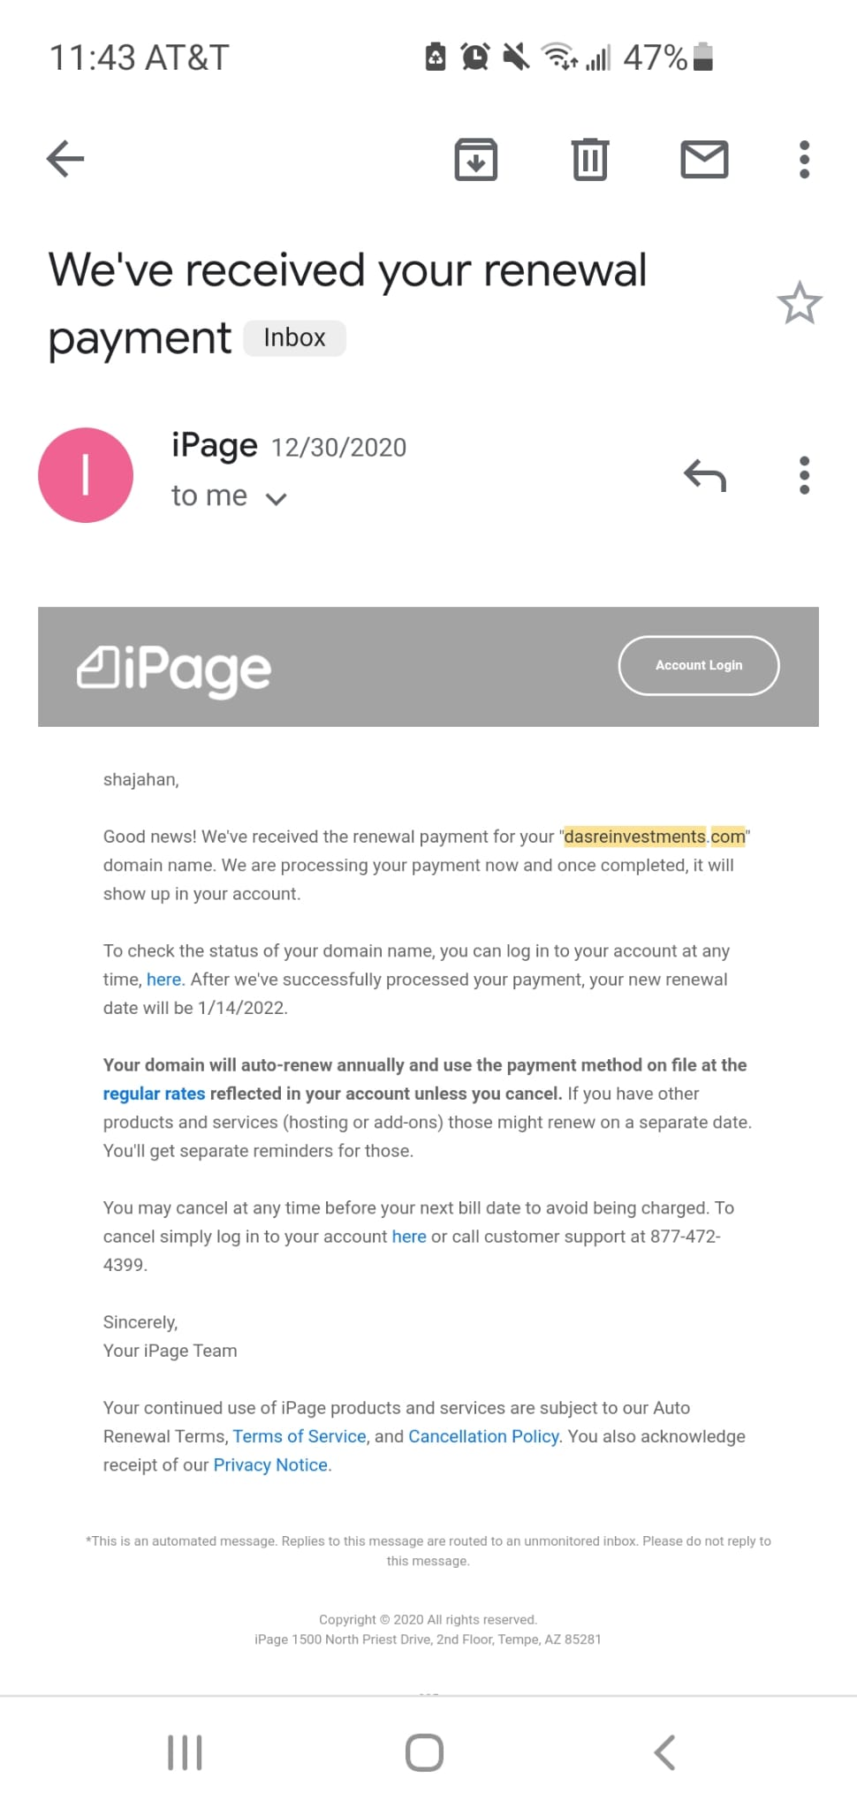

## 1.Home

index.html – Top Head

index-2.html – Main

index-5.html - Video Style

### Video - Time Lapse Houses Stock Video Footage

<https://www.youtube.com/watch?v=y9j-BL5ocW8>

<https://www.filmsupply.com/clips/new-york-city-aerial/27627>

<file:///C:/xampp/htdocs/in/index-5.html>

Selected:

<https://www.filmsupply.com/collections/new-york-city/5635>

## 2.About

## 3. Stratagey

### Multi-family

We invest in commercial real estate with high rental growth potential in working class neighborhoods.

We primarily focus in B & C class multi-family apartments with

* Median household income of $45,000+
* Population – 100,000+
* Consistent Job Growth
* Consistent Population Growth
* Low Crime
* Opportunity to Value-Add
* Easy commute to work
* Diverse Ethnicity
* Potential to return 8-10% Cash on Cash/80%+ total returns to our passive investors

### Property Size

We target B and C properties from 100 to 1000 units. We focus on this quantity of units because 100 units may be large for most small investors and 1000 units in too small for institutional investors, thus allowing for less competition.

### Creating Value

Repositioning (Micro and Macro) Property, Repositioning Tenants, Increasing Occupancy, Raise the Rents to Market Rents, and implementing RUBS.

### Geographic Focus

Acquire apartment complexes in blue collar communities. Our strategy is to purchase and appreciate these multifamily apartment complexes in the Southeast and Midwest.

### Value Adds

Buy Properties with Minor Rehab, Re-positioning, Deferred Maintenance, Below Market Rents, Low Occupancy, and Subpar Property Management and Appreciating the properties by taking advantage of Value Adds.

### Attractive Returns

we strive for cash-on-cash returns of at least 10% and cap rates of 7-10%. This high return rate, coupled with the equity built over time, make our multifamily investing approach a sought after option for any wealth building strategy.

### Clear Cut Exit Strategies

We Refinance our properties in 3-5 Years by taking advantage of Appreciation, and then investing the proceeds into Larger Assets.

## 4.Porttifilio

file:///C:/xampp/htdocs/in/portfolio.html#

<file:///C:/xampp/htdocs/in/product-details.html>

## 5.Form

<https://support.google.com/docs/answer/2917686?hl=en#zippy=%2Cchoose-where-to-store-responses>

<https://forms.gle/edWsiieJZbtGWWpL9>

<iframe src="https://docs.google.com/forms/d/e/1FAIpQLSfHygmt1RwKvDwjciKubnjKENZMDo7DX7SVOnOtGRpBGzD7sQ/viewform?embedded=true" width="640" height="2158" frameborder="0" marginheight="0" marginwidth="0">Loading…</iframe>

## **How to change owners**

1. Open the homescreen for [Google Drive](https://drive.google.com/), [Google Docs](https://docs.google.com/), [Google Sheets](https://sheets.google.com/), or [Google Slides](https://slides.google.com/).
2. Click the file you want to transfer to someone else.
3. Click ****Share**** or Share Share.
4. To the right of a person you've already shared the file with, click the Down arrow Down arrow.
5. Click ****Make owner****.
6. Click ****Done****.

After you make someone else the owner of a file, you can edit the file unless the new owner decides to change your access.

# Calendly Integration

<https://calendly.com/>

After Signup – it gives URL

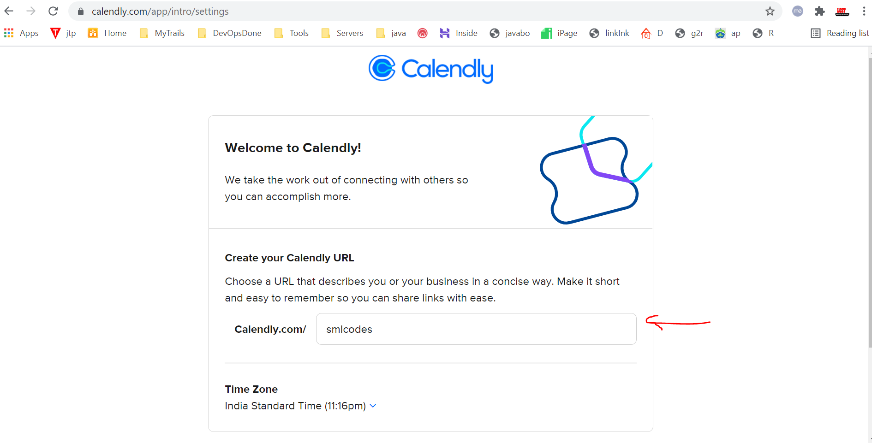

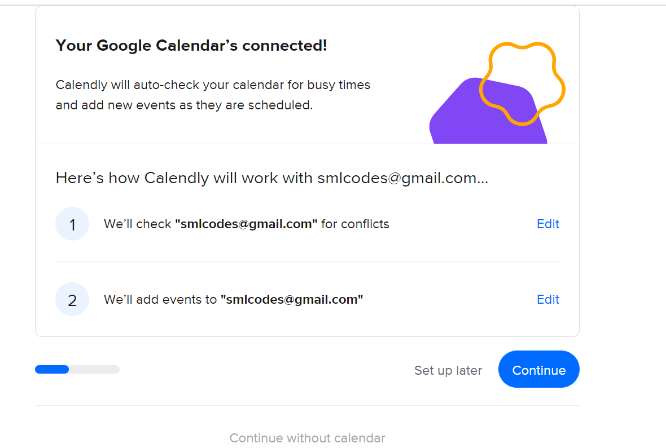

Select Available Hours

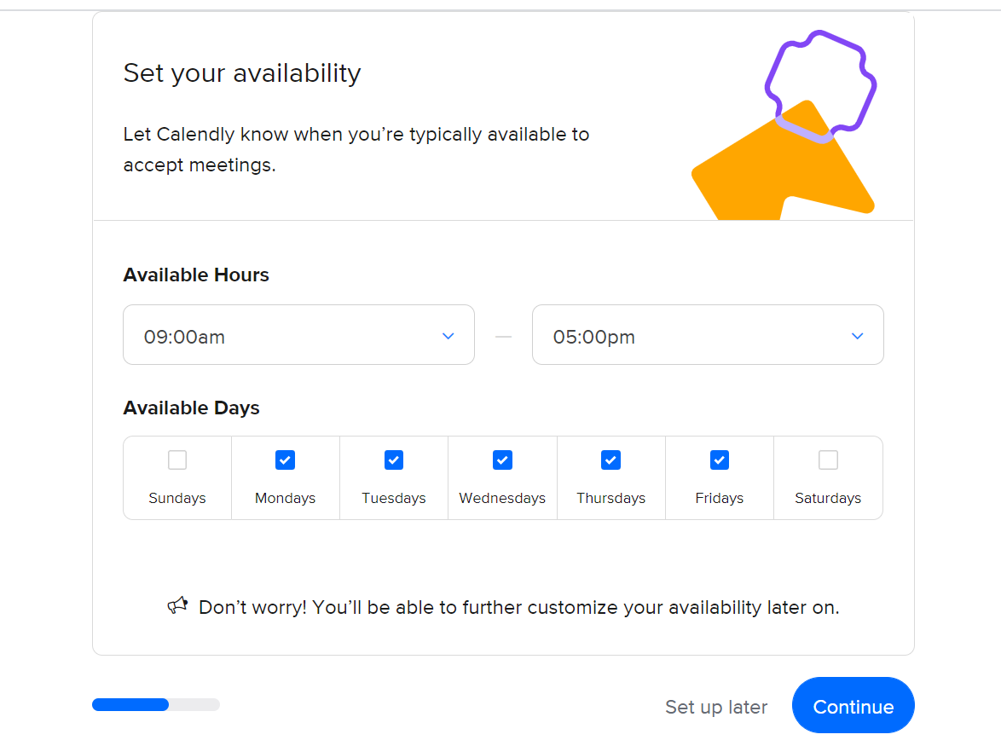

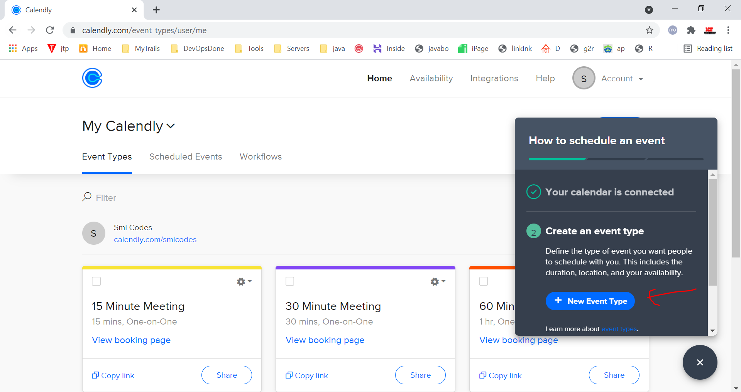

## Website Integartion

<https://thegoodalliance.org/tutorials/setup-integrate-calendly/>

Clcik on Share Button & Add to website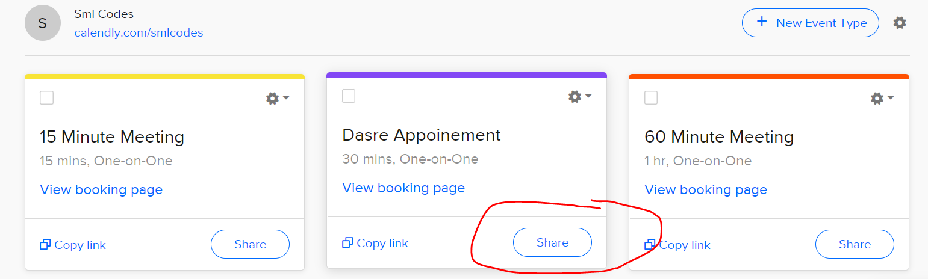

Select any option

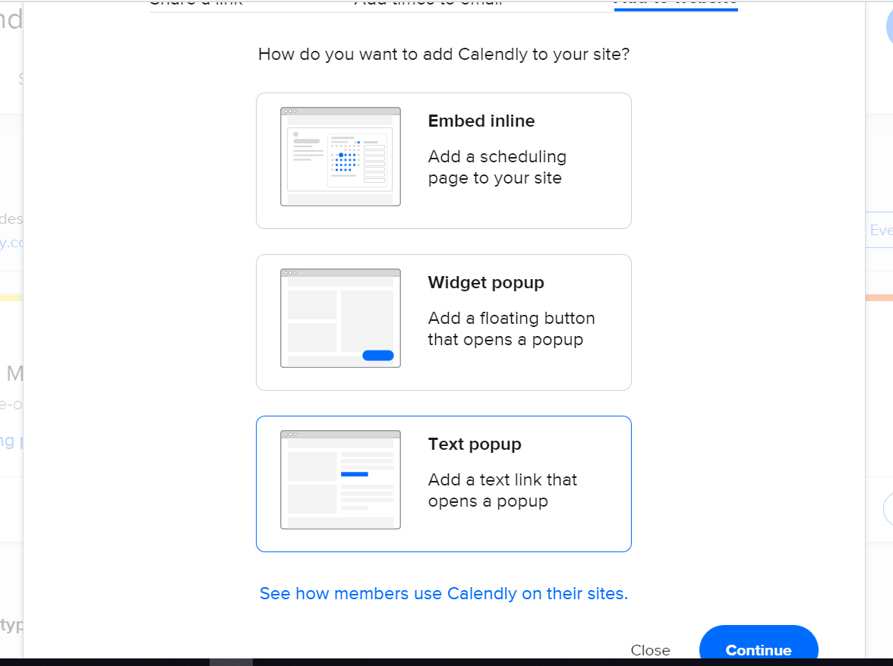

Copy Code 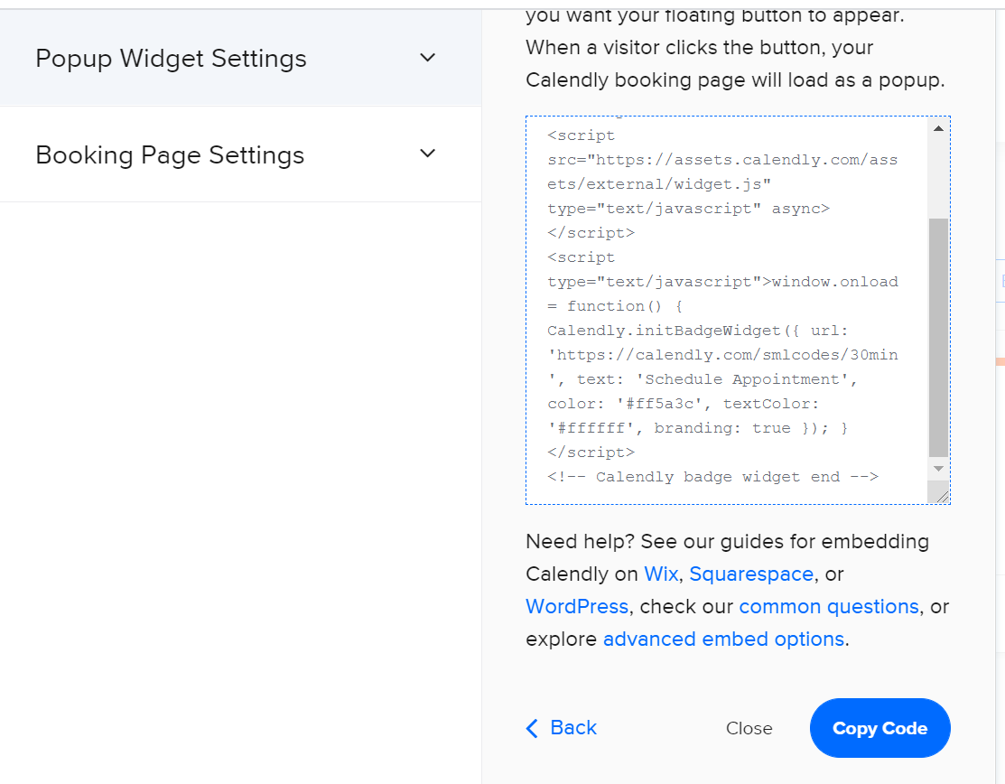

Paste in Footer

## Inline Pages

Index.php - Schedule Meeting

about.php - Schedule Meeting

# Customize Theme

DevTools failed to load source map: Could not load content for http://localhost:7777/in/js/bootstrap.min.js.map: HTTP error: status code 404, net::ERR_HTTP_RESPONSE_CODE_FAILURE

DevTools failed to load source map: Could not load content for http://localhost:7777/in/css/bootstrap.min.css.map: HTTP error: status code 404, net::ERR_HTTP_RESPONSE_CODE_FAILURE